Excel Project: Project Status Dashboard

Author: Emily Kokol-Rivera | Date: October 2025 | GitHub: <https://github.com/emilyannKR/excel-portfolio/blob/main/Project%20Manager%20Dashboard/Project_Manager_Dashboard.xlsx>

# Project Overview

This dashboard tracks and visualizes project performance across multiple departments using key metrics such as project status, completion rate, budget utilization, and timeline progress. The dataset includes project names, managers, start and end dates, financial data, and performance indicators. The outcome is a dynamic, Excel-based view of portfolio health that allows users to quickly identify which projects are on track, under budget, or at risk.

# Tools & Skills Demonstrated

* Excel Tables and Structured References
* COUNTIFS, COUNTA, and SUMPRODUCT for KPI calculations
* Conditional Formatting for color-coded indicators
* Data Bars and Percentage Calculations
* Dashboard Design and Layout Organization

# Dashboard Snapshot

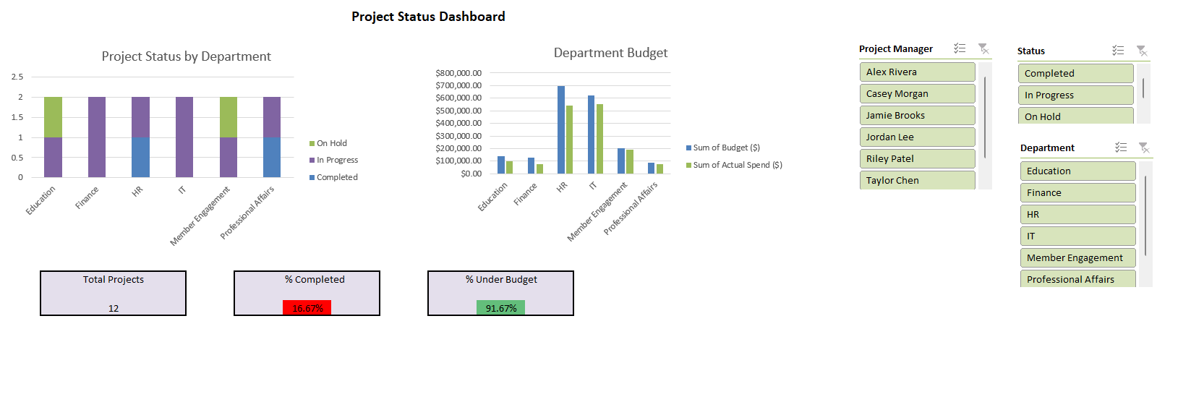

# Key Insights

* 16.7% of projects are currently completed.
* The majority of active projects are in progress and on schedule.
* A strong portion of projects remain under budget, indicating good cost control.

# Learning Reflection

This project strengthened my ability to translate raw operational data into performance metrics and automate KPI calculations using dynamic Excel formulas.